# Practical No: 01

Aim: Introduction to Tableau – Install, prepare data, navigate workspace, create visualizations, save/share workbooks.

Name :Hitesh Mhatre

Class: T.Y. Data Science

Roll no: 25 Subject: DVT Sign:

## Steps:

1. Go to the Tableau Public webpage: <https://public.tableau.com/app/discover>

[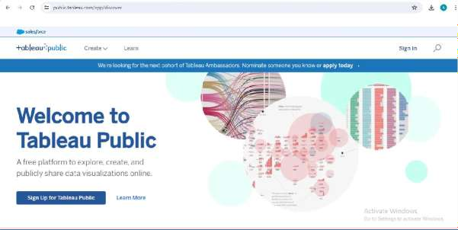](https://public.tableau.com/app/discover)

1. Click on “Create” and “Download Tableau Desktop Public Edition”

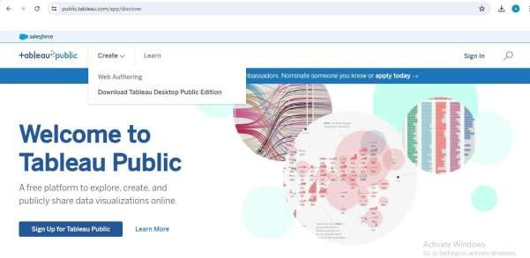

1. Click on “Download Tableau Public.”

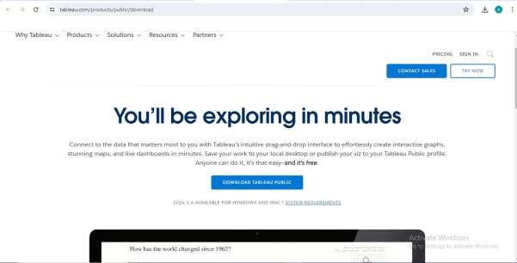

1. Fill the details and start downloading.

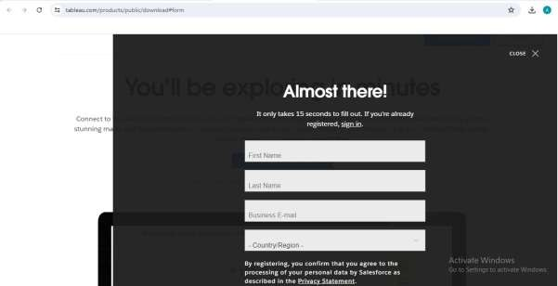

1. Open the downloaded installer and click on “Install”.

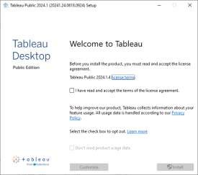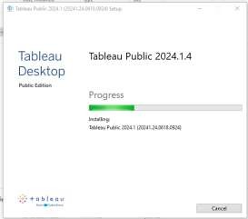

1. Open the Tableau Public.

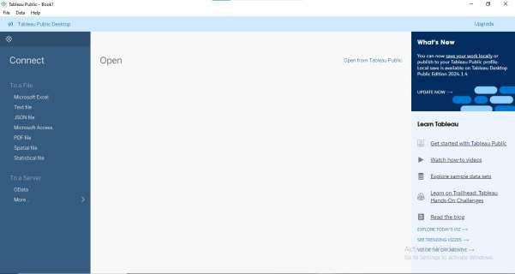

1. On the start page, under the "Connect" pane, choose “Microsoft Excel” and select an excel file (dataset) from the computer.

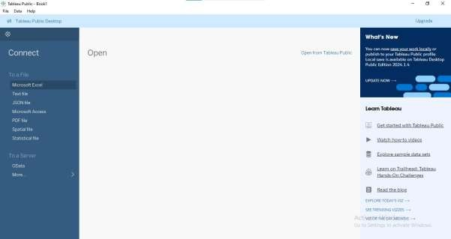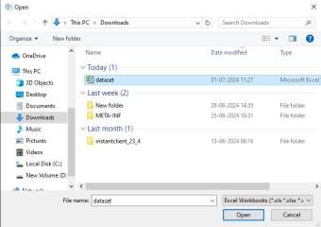

1. After connecting, Tableau will show the data source page. Rename the sheets and prepare data for visualization

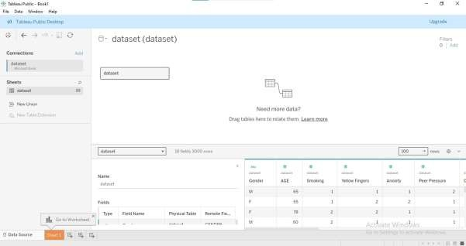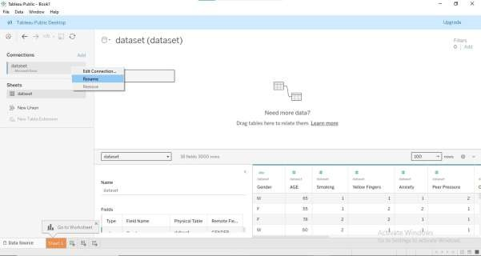

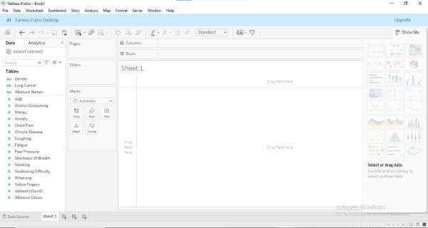

1. Drag a dimension to the Columns shelf and drag a measure to the Rows shelf to create bar chart.

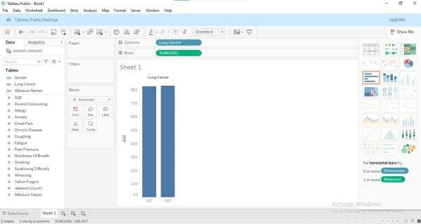

1. Go to File > Save As.
2. Choose a location on your computer and save the workbook with a .twb or .twbx extension.

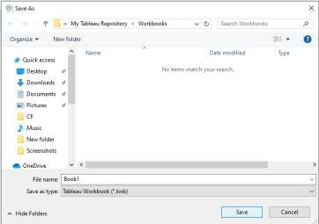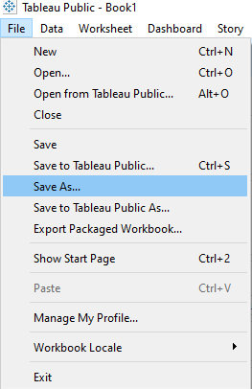

# Practical No: 02

Aim: Adding Data Sources – Set up connectors, select tables, perform joins/unions, edit metadata, add hierarchies/calculated fields, optimize performance.

Name: Hitesh Mhatre Class: T.Y.DS

Roll no: 25 Subject: DVT Sign:

**Set up connectors:**

1. Launch Tableau Public  On the start page, go to “Connect” pane.
2. 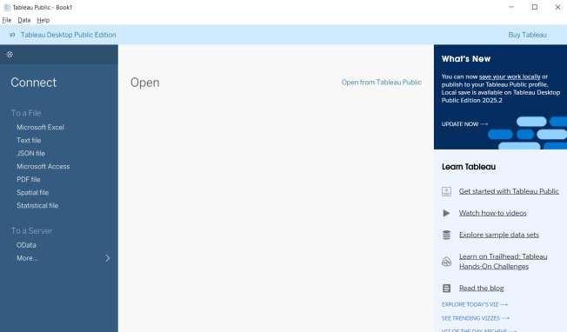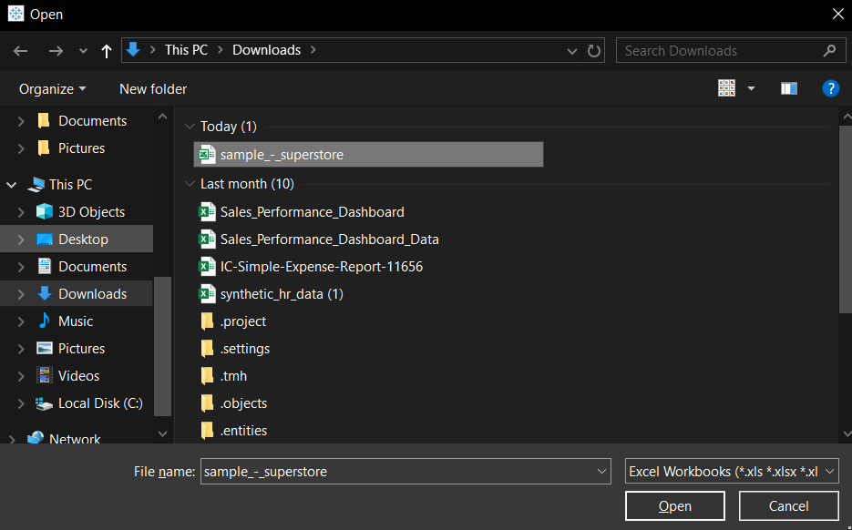Select “Microsoft Excel” as a Data Source and select the excel file containing dataset.

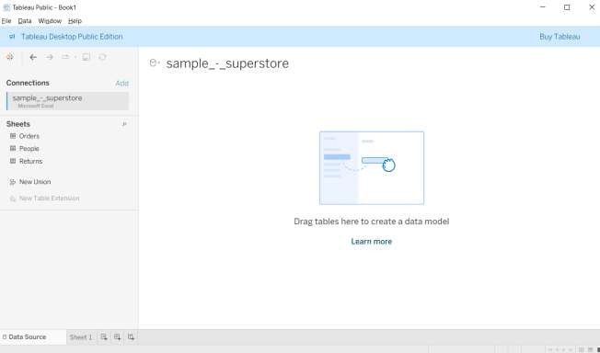

* **Selecting Tables:**
  1. Once the dataset is loaded, different tables within that dataset will be displayed.
  2. 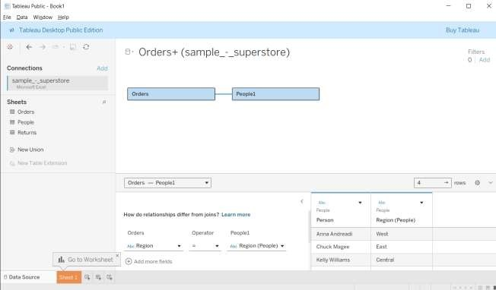Click on the particular table to preview it.
* **Performing Joins / Unions:**
  1. Drag the ‘Returns’ table onto the ‘Orders’ table in the canvas.

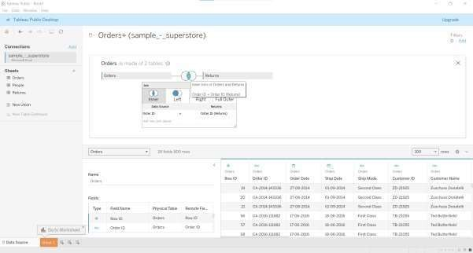

* 1. Configure the join type and join field

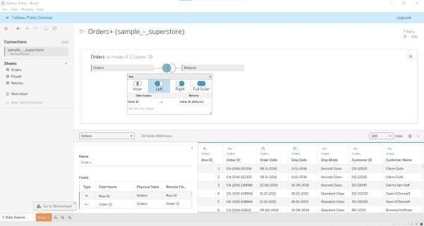

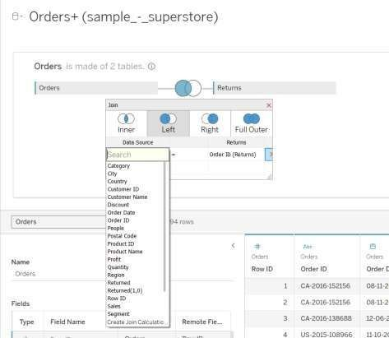

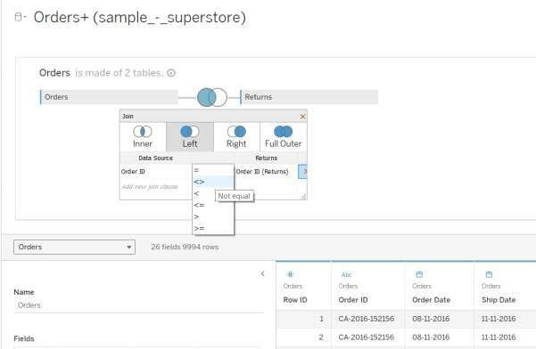

**Edit metadata:**

* 1. In the “Data Source” tab, right-click on the “Order Date” field and select “Rename”. Rename it to “Date of Order”.

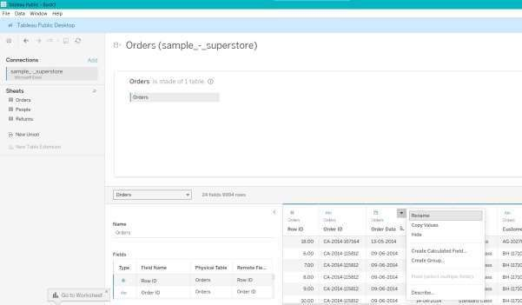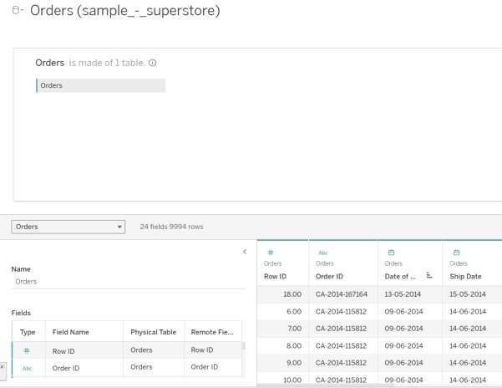

* 1. Change the data type of “Row ID” field from “Number(whole)” to “Number(decimal)”.

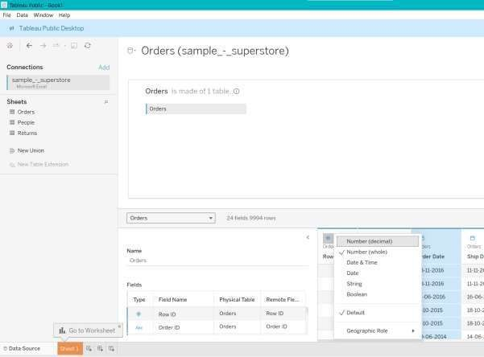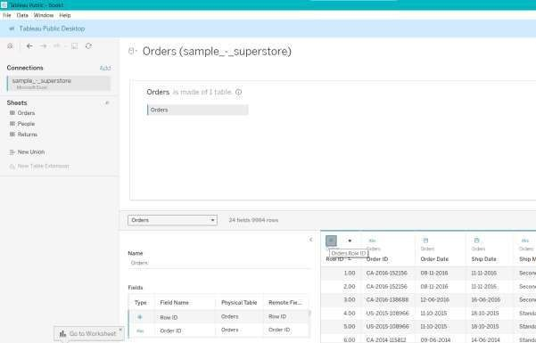

* 1. Create Alias for “Ship Mode” field by selecting “Aliases” option and set the value for

alias as “High Class” for Member “Standard Class”.

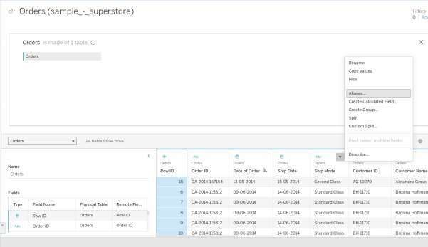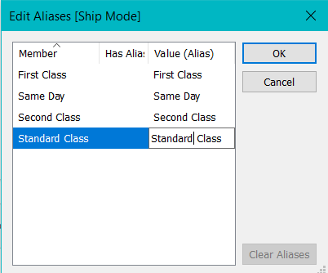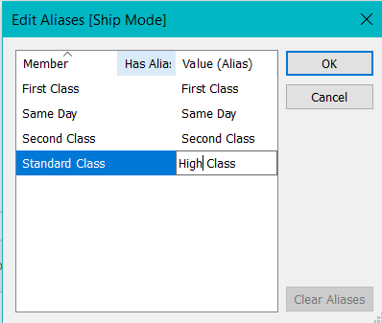

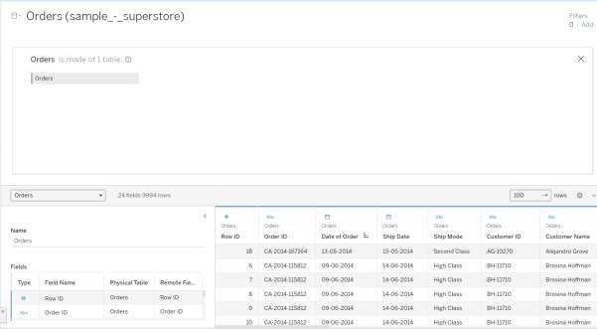

**Add Hierarchies / Calculated fields:**

* + - **Hierarchies:**
      1. In the “Data” pane, drag the “Category” field onto the “Sub-Category” field to create a hierarchy.

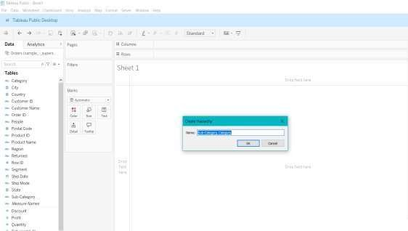

* + - 1. Name the hierarchy “Product Category”.

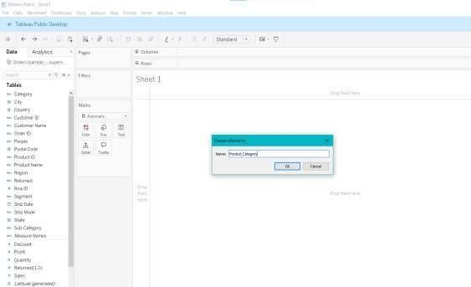

* + - 1. Add “Product Category” into Rows section, expand it and “Sales” into Columns section and visualize it.

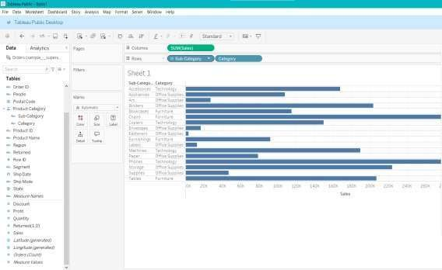

* + - **Calculated Fields**:
      1. Right-click in the “Data” pane and select “Create Calculated Field”.

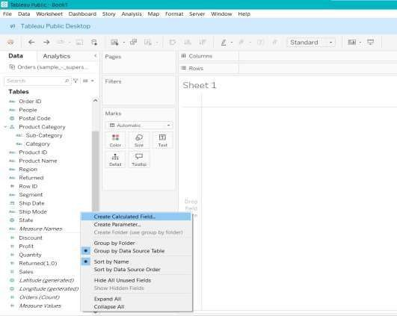

* + - 1. Name the field Profit Ratio.
      2. Enter the formula: “[Profit] / [Sales]” and Click “Ok”.

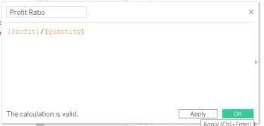

* + - 1. Add the newly created calculated field to Rows section and “Sub-Category” to Columns section and visualize it.

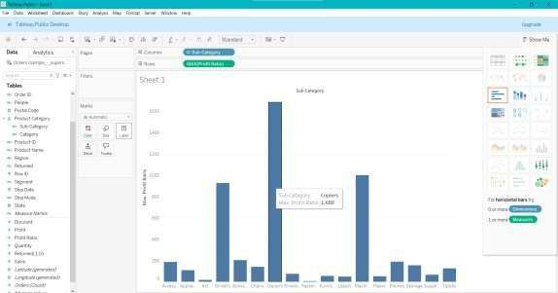

**Optimizing Performance:**

* + - **Filter Data:**
      1. Create a filter for profit field in the dataset.

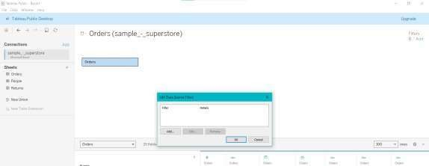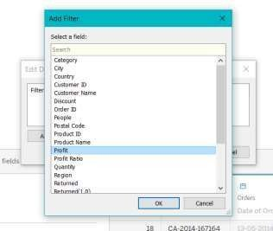

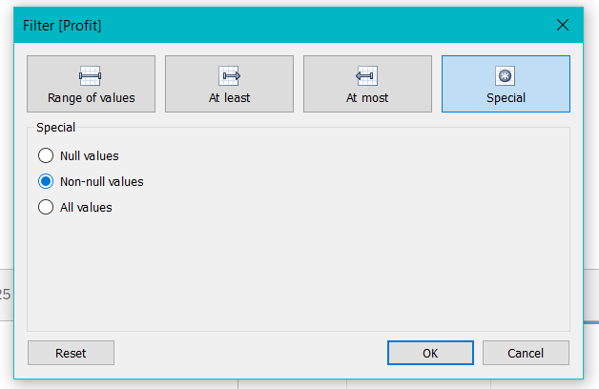

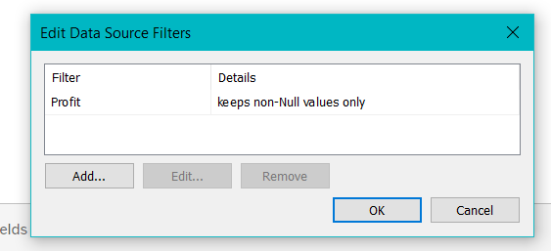

# PRACTICAL NO. 3

Creating Data Visualization

Name: Hitesh Mhatre Class: T.Y.DS

Roll no: 25 Subject: DVT Sign:

## Bar Graph:

A bar graph can be defined as a graphical representation of data,

quantities, or numbers using bars or strips. They are used to compare and contrast

different types of data, frequencies, or other measures of distinct categories of data.

Steps:

1. Connect to Data Source by selecting the appropriate connector (e.g., Excel, SQL Server, CSV).
2. Create a New Worksheet
3. Select Dimensions and Measures
   * Identify the dimensions (categorical data) and measures (numerical data) you want to visualize.
   * Drag a dimension (e.g., Product Category) to the Columns shelf.
   * Drag a measure (e.g., Sales) to the Rows shelf.
4. Choose the Bar Graph Type
   * Click on the “Show Me” panel on the right side of the screen.
   * Select the bar chart icon from the available chart types.
5. Customize the Bar Graph
   * Sort Bars: You can sort the bars in ascending or descending order by clicking on the sort button next to the axis labels.
   * Color: Drag a dimension or measure to the Color shelf to differentiate bars by color.
   * Labels: Drag a measure to the Label shelf to display data labels on the bars.
   * Tooltips: Customize the tooltips by dragging fields to the Tooltip shelf.

## Output:

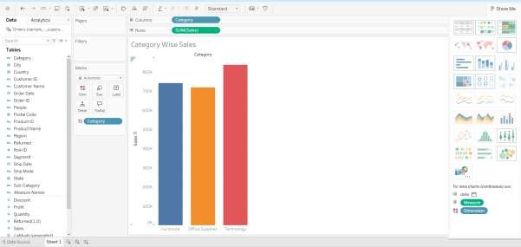

1. **Stack Bar graph:**

The stacked bar chart (aka stacked bar graph) extends the standard bar chart from looking at numeric values across one categorical variable to two.

Each bar in a standard bar chart is divided into a number of sub-bars stacked

end to end, each one corresponding to a level of the second categorical variable. Steps:

1. Follow the same three steps as creating a bar graph.
2. Create a stacked bar chart
   * Drag another categorical field (e.g., Sub-Category, Region) to the Color shelf on the Marks card. This will divide the bars into different segments (stacked).
3. Adjust the visualization
   * Ensure the Marks card is set to Bar.
   * If your bars are not stacking, click on the Analysis menu at the top, then Stack Marks, and make sure Automatic or On is selected.

## Output:

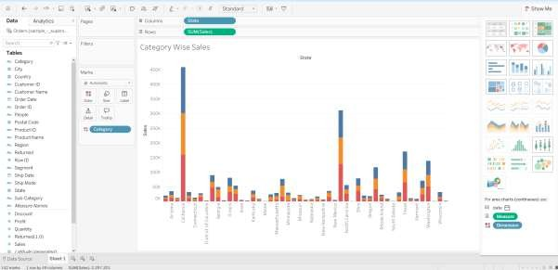

1. **Pie Chart:**

Pie charts can be used to show percentages of a whole, and represent

percentages at a set point in time. Unlike bar graphs and line graphs, pie charts do not show changes over time. The following pages describe the different parts of a pie chart.

Steps:

* 1. Follow the same three steps as we did while creating a bar graph.
  2. Add Data to the Chart
  3. Configure the Pie Chart
     + On the Marks card, change the mark type from Automatic to Pie.
     + Drag the dimension (e.g., Category) to the Color shelf on the Marks card to differentiate the slices by color.
     + Drag the same dimension (e.g., Category) to the Label shelf on the Marks card to display labels on the slices.
     + Optionally, drag the measure (e.g., Sales) to the Label shelf to show the value or percentage on each slice.
  4. Adjust and Format the Pie Chart.
  5. Add a Title and Final Touches.

## Output:

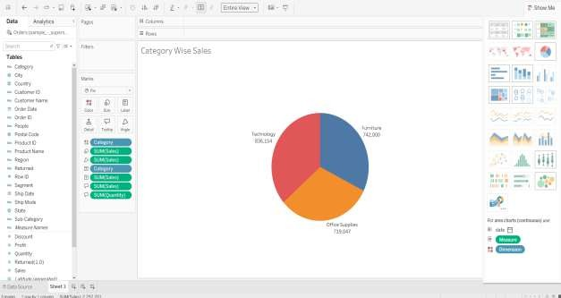

1. **Scatter plot:**

A scatter plot (aka scatter chart, scatter graph) uses dots to represent values for two different numeric variables. The position of each dot on the horizontal and vertical axis indicates values for an individual data point. Scatter plots are used to observe relationships between variables.

Steps:

1. Follow the same three steps we did while creating bar graph
2. Convert to Scatter Plot
   * By default, Tableau may not display the data as a scatter plot

immediately. To ensure it's a scatter plot, go to the “Show Me” panel on the right and select the scatter plot option (usually a set of dots in a grid).

## Output:

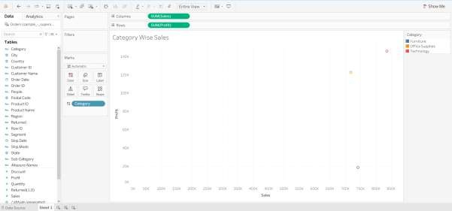

**E .Line chart:**

A line chart (aka line plot, line graph) uses points connected by line segments from left to right to demonstrate changes in value. The horizontal axis depicts a continuous progression, often that of time, while the vertical axis reports values for a metric of interest across that progression.

Steps:

1. Follow the same initial steps.
2. Change Marks to Line
   * By default, Tableau might not choose a line chart. Go to the "Marks" card, click on the dropdown menu, and select "Line."
3. Adjust Date Level.
4. Format the Chart.
5. Add Titles and Labels.

**Output:**

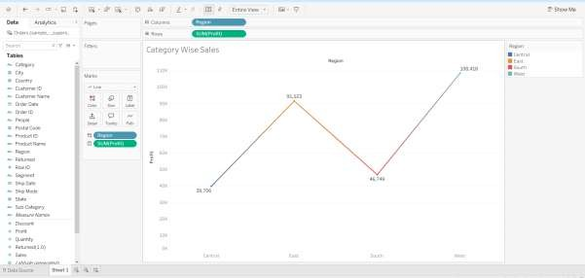

# Practical No. 04

Aim: Aggregate Functions and Calculated Fields – Use aggregates/calculated fields, handle text/date fields, apply logical functions /parameters, search text fields.

Name: Hitesh Mhatre Class: T.Y.DS

Roll no: 25 Subject: DVT Sign:

## Steps:

Importing Data:

1. Open Tableau Desktop and connect to the data source.
2. Select data source file and import the data into Tableau.

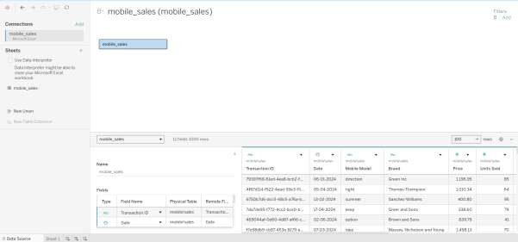

* 1. Aggregate Functions:
     1. SUM:

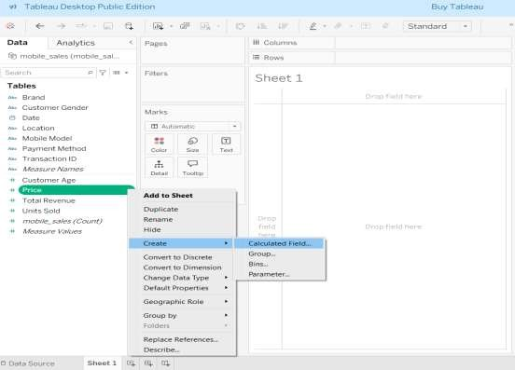

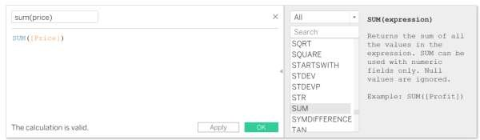

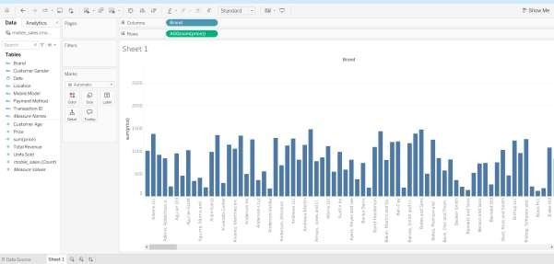

* + 1. AVG:

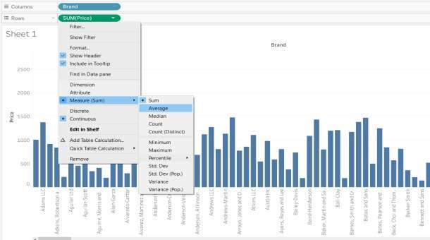

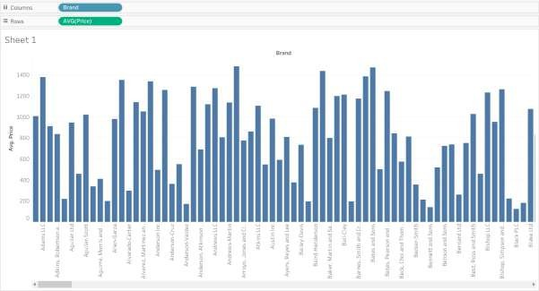

* + 1. COUNT:

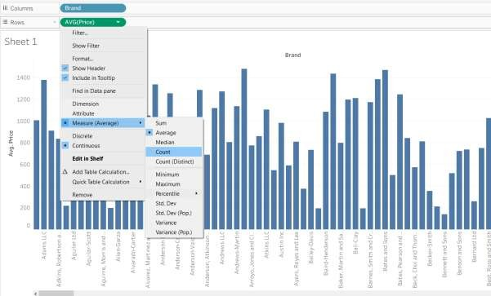

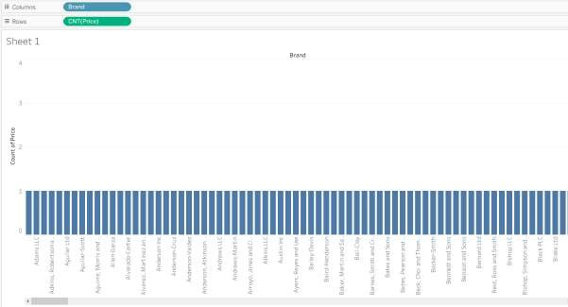

* 1. Calculated Fields:

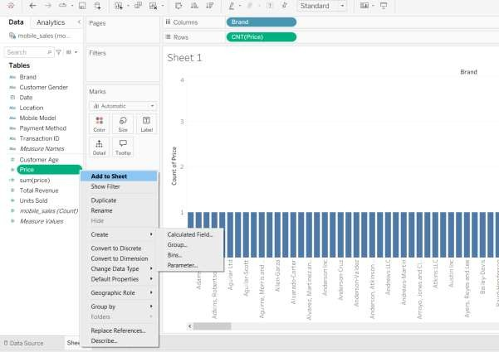

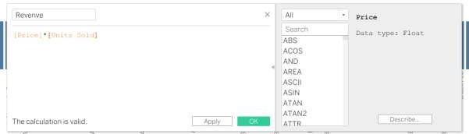

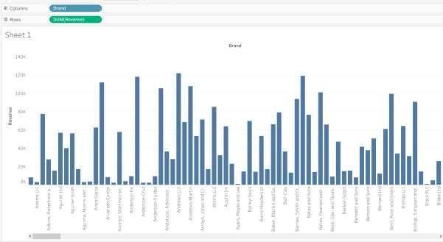

* 1. Text Functions:

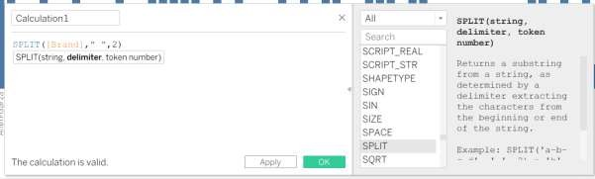

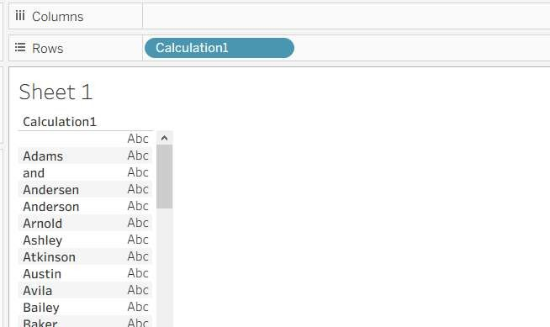

* 1. Date Functions:

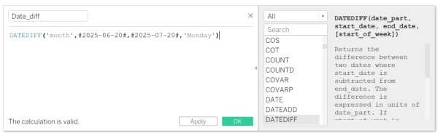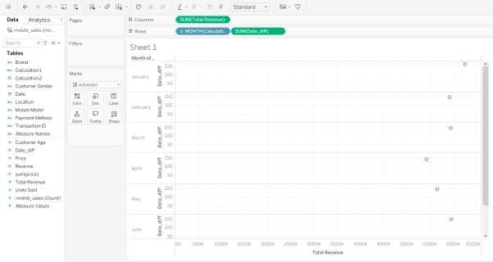

* 1. Logical Functions:

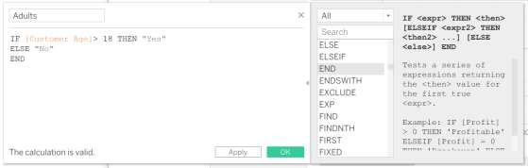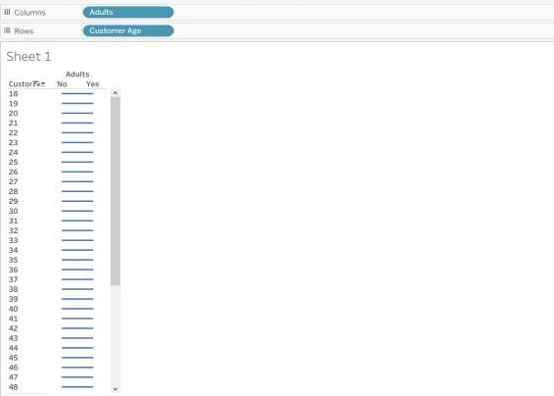

* 1. Parameters:

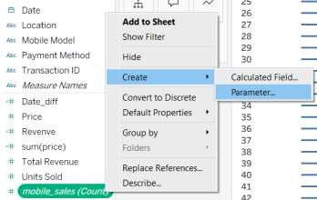

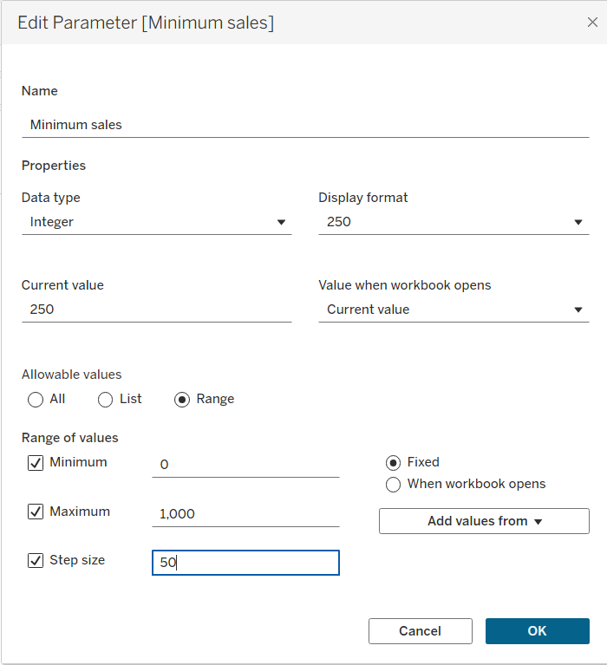

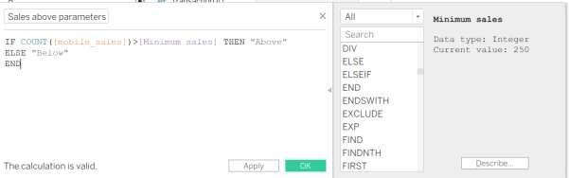

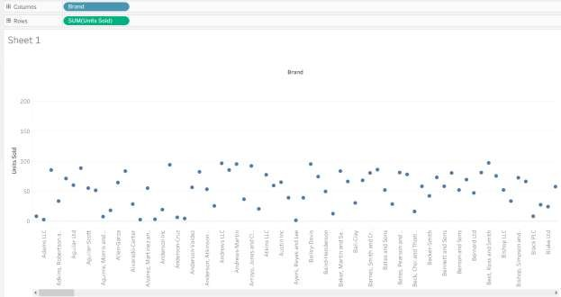

* 1. Searching text fields:

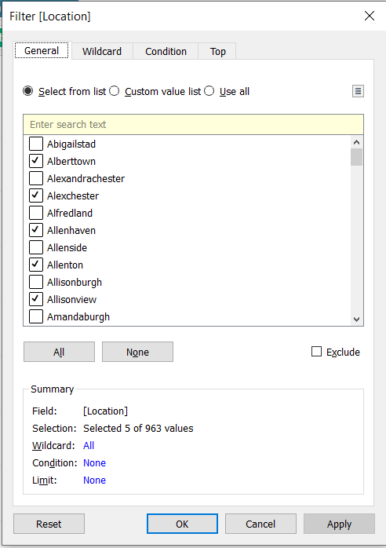

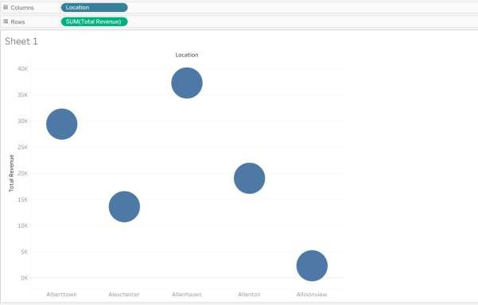

# Practical No. 5

Aim : Table Calculations and Level of Detail Calculations - Perform different calculations, apply quick/customized table calculations, implement level of detail expressions.

Name: Hitesh Mhatre Class: T.Y.DS

Roll no: 25 Subject: DVT Sign:

## Steps: Percent of Total Calculation

* 1. Connect to Data Source by selecting the appropriate connector (e.g., Excel, SQL Server, CSV).
  2. Create a New Worksheet
  3. Drag your measure (e.g., Sales) to the Rows or Columns shelf.
  4. Right-click the measure field in the shelf and select Add Table Calculation.
  5. In the Table Calculation dialog box:
     + Choose Percent of Total from the Calculation Type drop-down.
     + In the Compute Using section, choose how the percentage should be

calculated (e.g., across the entire table, down rows, across columns, etc.).

* 1. Click OK to apply the calculation.

The values will now display as a percentage of the total.

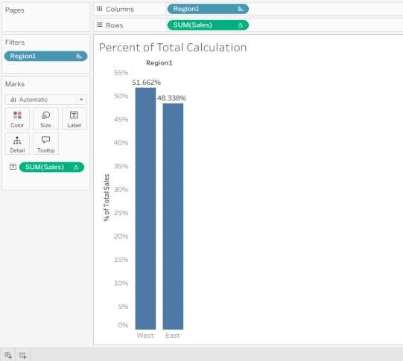

## Steps: Running Table Total Calculation

* 1. Connect to Data Source by selecting the appropriate connector (e.g., Excel, SQL Server, CSV).
  2. Create a New Worksheet
  3. Drag your measure (e.g., Sales) to the Rows or Columns shelf.
  4. Right-click the measure field and select Add Table Calculation.
  5. In the Table Calculation dialog box:
     + Choose Running Total from the Calculation Type drop-down.
     + In the Compute Using section, select how the running total should be calculated (e.g., across rows, down rows, etc.).
  6. 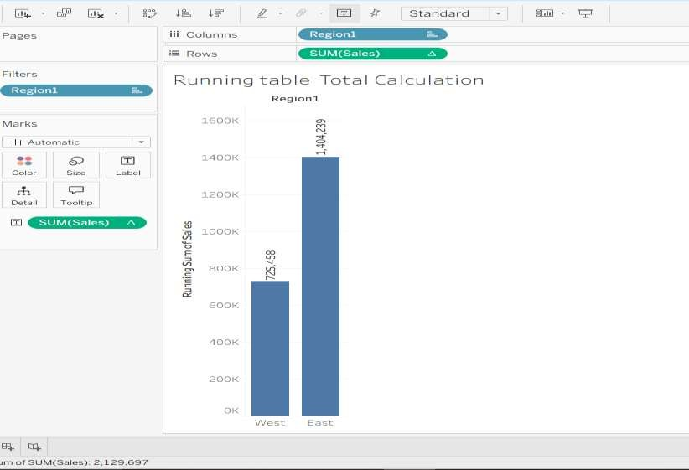Click OK to apply the running total.

## Steps: Percent Difference Calculation

* 1. Connect to Data Source by selecting the appropriate connector (e.g., Excel, SQL Server, CSV).
  2. Create a New Worksheet
  3. Drag your measure (e.g., Sales) to the Rows or Columns shelf.
  4. Right-click the measure and select Add Table Calculation.
  5. In the Table Calculation dialog box:
     + Choose Percent Difference from the Calculation Type drop-down.
     + In the Compute Using section, select how the percent difference should be calculated (e.g., table down, table across).
  6. 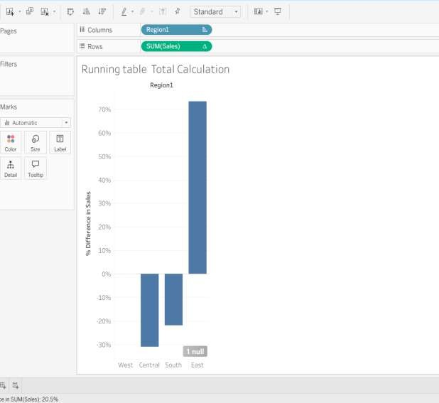Click OK to apply the percent difference.

## Steps: Rank Calculation

* 1. Connect to Data Source by selecting the appropriate connector (e.g., Excel, SQL Server, CSV).
  2. Create a New Worksheet
  3. Drag your measure (e.g., Sales) to the Rows or Columns shelf.
  4. Right-click the measure and select Add Table Calculation.
  5. In the Table Calculation dialog box:
     + Choose Rank from the Calculation Type drop-down.
     + Choose how you want to rank (e.g., highest to lowest or lowest to highest).
     + In the Compute Using section, specify how the rank should be computed (e.g., down rows, across the table).
  6. Click OK to apply the rank calculation.

If you want to adjust the ranking method (e.g., Dense Rank, Unique Rank),

click Advanced in the Table Calculation dialog box to choose from the different ranking methods.

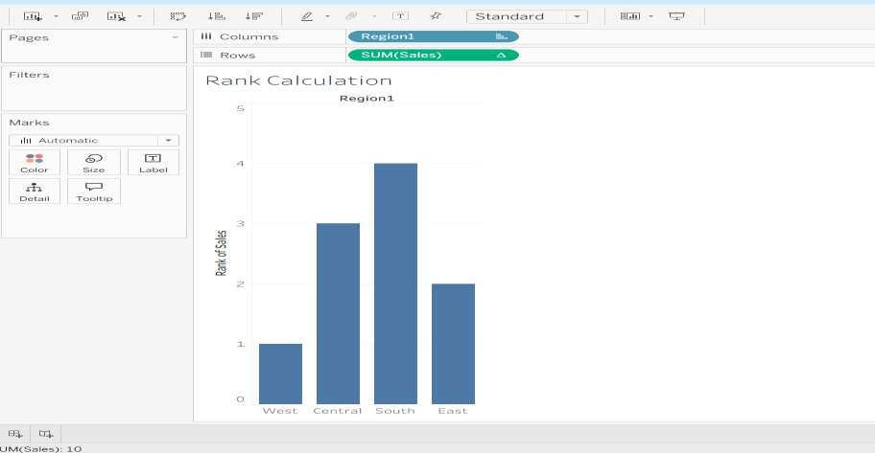

## Steps: Moving Average Calculation

1. Connect to Data Source by selecting the appropriate connector (e.g., Excel, SQL Server, CSV).
2. Create a New Worksheet
3. Drag your measure (e.g., Sales) to the Rows or Columns shelf.
4. Right-click the measure and select Add Table Calculation.
5. In the Table Calculation dialog box:
   * Choose Moving Average from the Calculation Type drop-down.
   * In the Compute Using section, specify how the moving average should be computed (e.g., down rows, across columns).
   * In the Moving Calculation settings, specify the Number of Previous Values to include in the average (e.g., a 3-period moving average).
6. 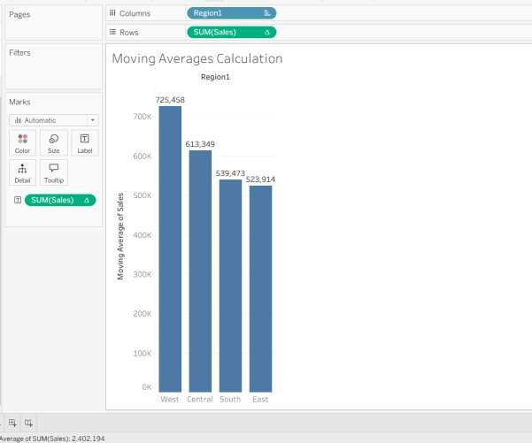Click OK to apply the moving average.

# Practical No. 06

Aim: Maps in Tableau – Create symbol/filled/density maps, add layers/ pie charts, use viz in tooltip, explore alternative map service, analyse

spatial data.

Name: Hitesh Mhatre Class: T.Y.DS

Roll no: 25 Subject: DVT Sign:

## Steps:

**Symbol Map:**

1. Drag the “Country” dimension in Columns or Rows section.
2. Click on “Show Me” and select “Symbol Map”.
3. In the Marks card select “Shape” and add “Profit” measure to “Size”.
4. Click on the “Shape” to change the symbols.

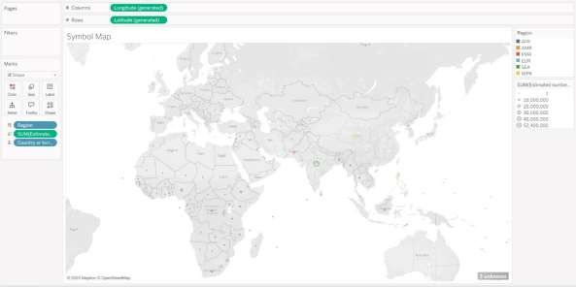

## Filled Map:

* 1. Drag the “Country” dimension in Columns or Rows section.
  2. Click on “Show Me” and select “maps”.
  3. In the Marks card select “Map” and add “Profit” measure to “Color”.
  4. 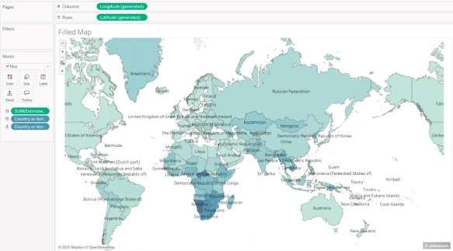Add “Country” dimension to “Label”.

## Density Map:

1. Drag the “Country” field to the view.
2. Change the “Marks” type to “Density” .
3. Add “Profit” measure to “Color”.

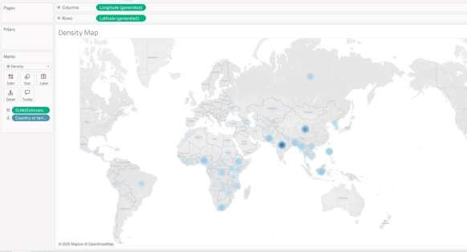

## Adding Map Layers:

1. To add map layers in already created symbol map, Go to “Map” tab in the ribbon.
2. Select the “Background Layers” option.
3. In the “Background Map Layers” pane, change the map style and add layers by selecting Background Map Layers.

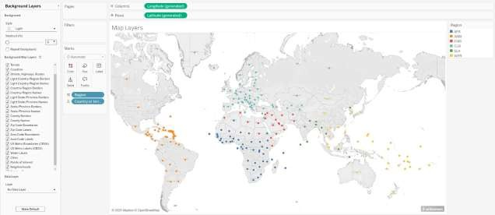

## Adding Pie Charts:

1. Create the Symbol Map using “Country” dimension.
2. In the “Marks” card and “Country” in “Label”.
3. Change the marks type to “Pie” and Add “Profit” measure into “Size” and “Category”

dimension to “Color” section.

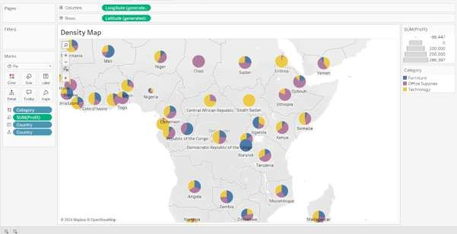

## Using Viz in Tooltip:

1. Create a bar chart of Category wise profit using “Profit” measure and “Category” dimension.
2. In the symbol map view, click on “Label”
3. Click on “Insert” and then “Sheets”. Select the Sheet where bar chart is created.

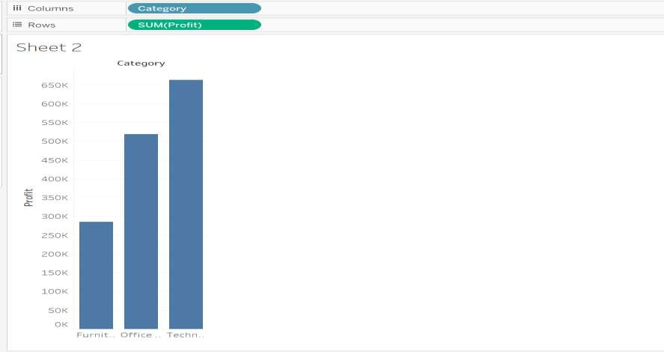

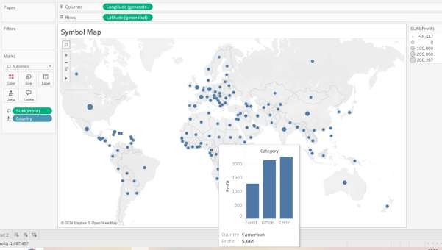

# Practical No. 07

Aim: Advanced Analytics in Tableau –Identify trends / forecasts / clusters, utilize analytics pane, incorporate lines / forecasts, perform cluster analysis**.**

Name:Hitesh Mhatre Class: T.Y.DS

Roll no: 25 Subject: DVT Sign:

**Steps:**

1. **Identifying Trends in Tableau**
   1. Open the Tableau and load the sample superstore dataset.
   2. Drag Order Date to columns shelf and expand it to the months.
   3. Drag Sales field to rows shelf and create a line chart.
   4. Click on the Analytics Pane next to the data tab.
   5. Under the model section select the Trend Line and drag the Trend Line to line chart.
   6. Right click on the trend line, select the format and change color of the Trend Line.

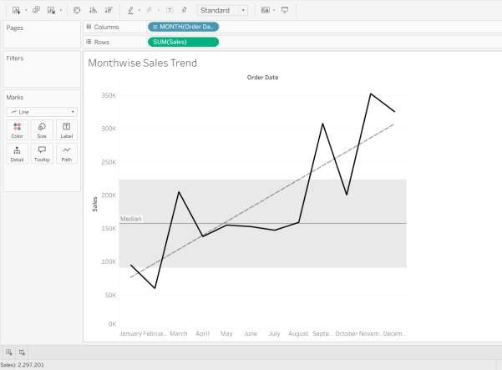

1. **Adding Forecasts in Tableau:**
   1. Create a line chart of Order Date and Profit by dragging Order Date to columns shelf and Profit to rows shelf.
   2. In the Analytics Pane, select the forecast option.
   3. Drag the forecast option to line chart.
   4. Right click on forecast area in the chart and select edit.
   5. In the Edit Forecast window set the Forecast length of 6 years.

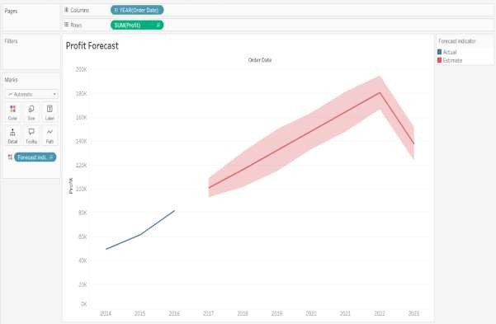

1. **Performing Cluster Analysis in Tableau:**
   1. Drag Profit to rows shelf and Sales to columns shelf to create scatter chart.
   2. Drag City to the detail in the Marks card.
   3. In the Analytics Pane, select the cluster option.
   4. Drag the cluster option to scatter chart.
   5. Change the colors of clusters using color option in the marks card.

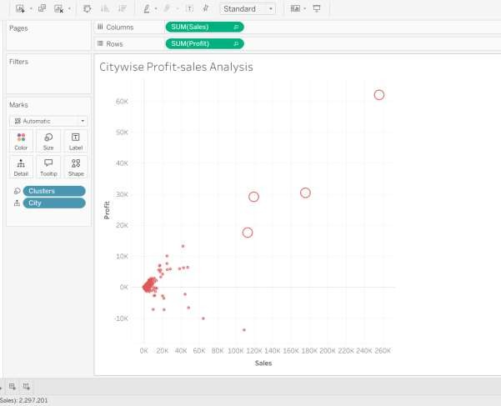

**Practical No: 08**

Aim: Interactive Dashboards - Considerations for dashboard creation, create/place charts, add titles/navigation/buttons/actions.

Name:Hitesh Mhatre Class: T.Y.DS

Roll no: 25 Subject: DVT Sign:

## Steps:

* + 1. Open the tableau public and connect to lung cancer data source.
    2. Drag the “Alcohol Consuming” dimension in the columns section and count of dataset in rows section.
    3. Drag the “Lung Cancer” dimension to color section to make bar chart.

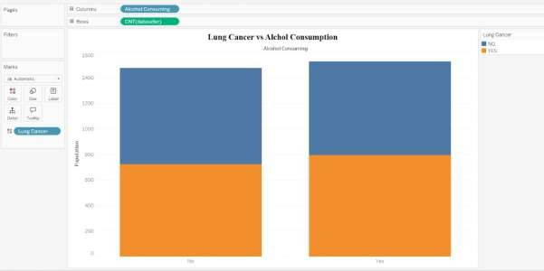

* + 1. Create the new sheet. To draw the doughnut chart, create the dummy field by putting 0 in calculation field and name it as dummy.
    2. Put the dummy field in the rows section twice, select the last field added right click and select dual axis.
    3. Format the chart using “lung cancer” and dataset count field.

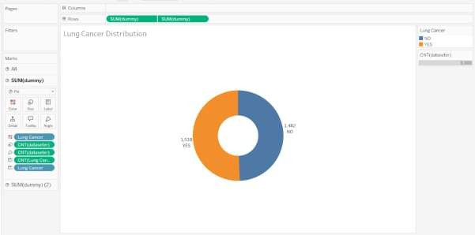

* + 1. Create the new sheet. To draw the doughnut chart, create the dummy field by putting 0 in calculation field and name it as dummy.
    2. Put the dummy field in the rows section twice, select the last field added right click and select dual axis.
    3. Format the chart using “chest pain” and dataset count field.

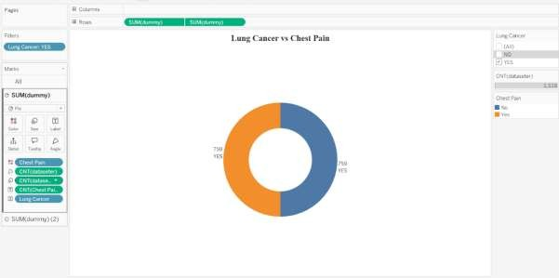

* + 1. Visualize the “Age” field by dragging the age filed into rows section.
    2. Click on “Show Me” and select “Histogram”.

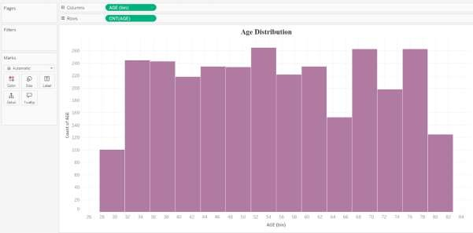

* + 1. Create a bubble chart by using “Gender” dimension and dataset count.

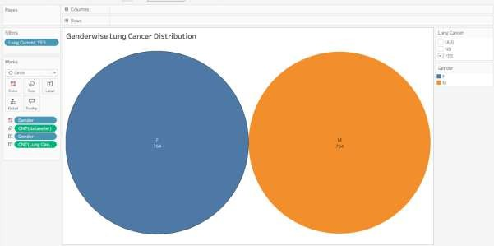

* + 1. Click on the dashboard icon in the bottom of the sheet to create dashboard.
    2. Select the device type and adjust the height and width of the dashboard.
    3. Drag the “text” object in the dashboard and insert the text “Lung Cancer Analysis”. Format it.
    4. Insert the sheets in which visualizations created to the dashboard.
    5. Go to format tab and select dashboard and format the dashboard and save it.

